KS1000/3000 Operator
Component List
Item | Content | Quantity | Brand | Type and Specification
ONE | KBB  Length of operator：4300 mm  KS1000 automatic sliding door operator：  Width of operator：165 mm  Height of operator：200 mm  KS3000 automatic door operator：  Width of operator：185 mm  Height of operator：105mm | 1 set | KBB | 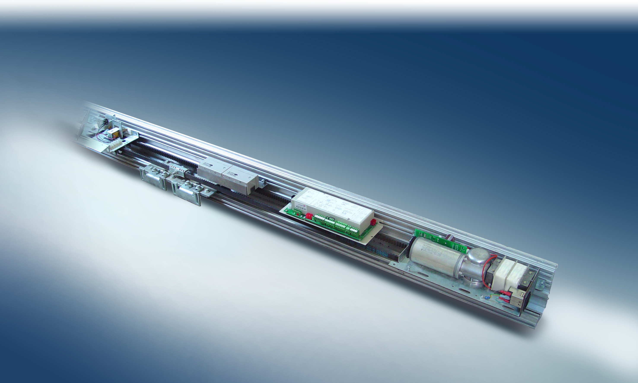
(ONE) | Control System
1 | Motor | 1 set | Dunkermotoren | 100W
2 | Decelerator | 1 set | Dunkermotoren | SG80
3 | Control unit | 1 set | PHILIPS | PHILIPS chip, Module design
4 | Radar | 2 sets | BEA | Infrared， Eagle 5 & 6
5 | PSA control panel | 1 set | KBB | 50m wire control，Can not use together with (THREE) 5
(TWO) | Mechanical parts
1 | Rail profile(Supporting beam) | 1 set | KBB | High strength, 5mm thickness
2 | Durable rail | 1 set | KBB | Special nylon, durable, quiet and self-lubricated
3 | Carriage wheel unit | 4 sets | KBB | Galvanized and adjustable
4 | Belt clip | 2 sets | KBB | Galvanized
5 | Drive timing belt | 1 pcs | KBB | Durable and anti-expanded
6 | Reversed wheel | 1 set | KBB | Galvanized
7 | Stopping device | 4 pcs | KBB | Galvanized, shock absorbing treatment
(THREE) | Optional parts (The optional items below are not calculated in the quotation )
1 | Double motor drive device | 1 set | Dunkermotoren | 100W
2 | Electro-mechanical lock | 1 set | KBB | 24V Bi-static working mode
3 | Back up battery | 1 set | KBB | 24V 30 minutes keep operating capacity
4 | Operator cover | 1 pcs | KBB | Aluminum 6063
5 | Key switch | 1 pcs | KBB | 4 splines
6 | Safety beam | 1 set | BEA | Infrared
In order for creation and development, KBB will keep the right to modify and improve this component list。

